**Winners of Scottish Young Musicians Ensemble of the Year and Brass Ensemble of the Year revealed.**

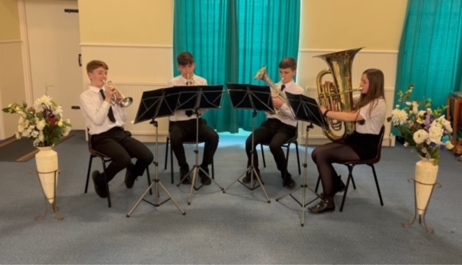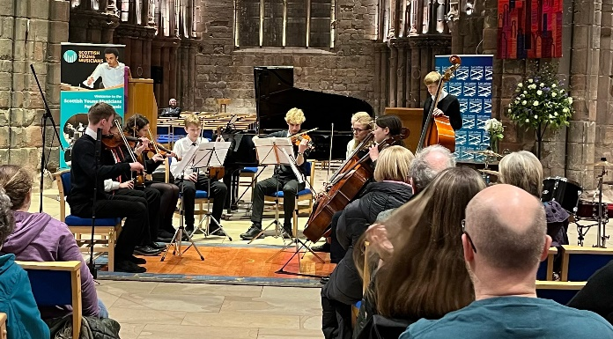

*(Left: East Lothian Council Instrumental Music Service Senior String Ensemble. Right: Stranraer Brass Ensemble)*

Scottish Young Musicians, Scotland’s festival of music competitions, gives young musicians from around the country the chance to compete to win career-enhancing prizes, perform live on a national stage in front of internationally renowned judges, and push their skills like never before.

After an online competition which attracted entries from across the country, **East Lothian Council Instrumental Music Service Senior String Ensemble** have been announced as the 2023 winners of **Scottish Young Musicians Ensemble of the Year**, which for the first time was open to ensembles playing any genre or grouping of instruments.

Thanks to a generous donation from Dr Ursula Jones OBE, there was also a special prize for one exceptional brass ensemble donated in honour of her late husband Philip Jones CBE, who founded one of the world’s most celebrated brass ensembles, The Philip Jones Brass Ensemble. This year’s prize was won by **Stranraer Brass Ensemble**, who won the first ever Scottish Young Musicians Ensemble of the Year in 2022.

Ensemble of the Year was open to ensembles of 3 to 12 players of any genre or grouping of instruments where members played together regularly in a formal group from a school or recognised music organisation. All members had to be school students in Scotland but there was no minimum age or standard. One ensemble was selected to represent each local authority, recognised music organisation, and Scotland's independent schools.

The chosen entries then submitted videos of their performances to a panel of esteemed adjudicators, made up of **John Wallace**, Convenor of MEPG, **Arlene Macfarlane**, Director of Scottish Schools Orchestra Trust, **Laura Gardiner**, Foundation Director of The Benedetti Foundation, and the award-winning Scottish marimbist and percussionist **Calum Huggan**.

**John Wallace, Convenor of the Music Education Partnership Group and one of the judges for Brass Ensemble of the Year, said:** *“It was heart-warming to see such an enthusiastic response to the ensemble and brass competitions. The overall winning entry, from East Lothian, and the winning brass ensemble, from Stranraer, were remarkable for their musicality and panache. They were able to communicate their musical message through the microphone directly to the heart and soul as well as the ears of our adjudication team. Every entry had something special to say but these two were extra special.”*

Both ensembles will now receive a cash prize to further their musical experiences, a Maid of Morven Trophy designed by Alexander Stoddart, The King’s Sculptor in Ordinary, and an all-expenses paid trip to play a prime slot at the Solo Performer of the Year National Final at The Royal Conservatoire of Scotland on Sunday 21 May.

In 2023, local authorities covering 99% of Scotland’s population are taking part in **Scottish Young Musicians Solo Performer of the Year**, giving opportunities to more young people who would like to compete in Scotland’s only music competition where funding and expertise is offered to every school and Local Authority. The competition is open to all young musicians who go to school in Scotland, whatever age or standard, and each area will select their best local soloist to compete at the National Final at the Royal Conservatoire of Scotland on Sunday 21 May 2023. The final will be hosted by **Jamie MacDougall** and prizes and internationally-renowned judges are due to be announced soon.

**Jonatan Gawn, Team Manager at East Lothian Council Instrumental Music Service, said:** *“Inspired by the Scottish Young Musician competition last year, East Lothian Council Instrumental Music Service now have Senior Bagpipe, Brass, Woodwind and String Ensembles. These ensembles are a unique opportunity for our more experienced young musicians to come together to enjoy performing in a chamber music setting. It was great to hear the high standard of all our ensembles, at our regional Scottish Young Musicians event, and I’m delighted that our young people’s efforts have been rewarded with this incredible opportunity to perform at the national final.”*

**Angela Miller, Conductor of Stranraer Brass Ensemble, said:** *“I am continually amazed by the progress and success of these young musicians. Each rehearsal is filled with hard work, fun and laughter making it a privilege to work with them. I look forward to seeing what the future holds for the Stranraer Brass Ensemble.”*

For more information, please visit [www.scottishyoungmusicians.com](http://www.scottishyoungmusicians.com) or follow the festival on [Facebook](https://www.facebook.com/scottishyoungmusicians/), [Twitter](https://twitter.com/SYMusicians) and [Instagram](https://www.instagram.com/scottishyoungmusicians/).

**ENDS/**

**IMAGES AVAILABLE [HERE](https://thecornershoppr.sharepoint.com/:f:/s/Clients/EvmQ6yyqbFpGlNYUL0nxXT8BNYPXi86LOUVAgSW_ZDDKQA?e=qbV5NO)**

**Press Contact:**

**For any press enquiries on Scottish Young Musicians, please contact**

**Hannah Knox** [hannahk@thecornershoppr.com](mailto:hannahk@thecornershoppr.com) **/ 07783748880**

**NOTES TO EDITORS**

**About Scottish Young Musicians**

The story started over 20 years ago when brothers Alan and Brian Kerr founded the North Ayrshire Young Musician Competition. It has flourished ever since under the stewardship of Mae Murray and over 20,000 young musicians have enjoyed taking part. From this grew the idea of bringing the Scottish Young Musicians competitions to the whole of Scotland - and that is what they are now setting out to do. Alan is now the Chair of Scottish Young Musicians, which aims to have a music competition in every school in the country and to have as many students participate in the life-skills benefits that this brings.

**About MEPG**

The Music Education Partnership Group (MEPG) will oversee the running of the Scottish Young Musicians Competitions. MEPG brings together stakeholders in music and education across Scotland. MEPG is a registered charity and members organisation which aims to tackle inequity, help young people to realise their potential and challenge perceptions of music education.