Scottish Young Musicians, Scotland’s national festival of music is back and bigger than ever, with entries now open for 2023 competitions
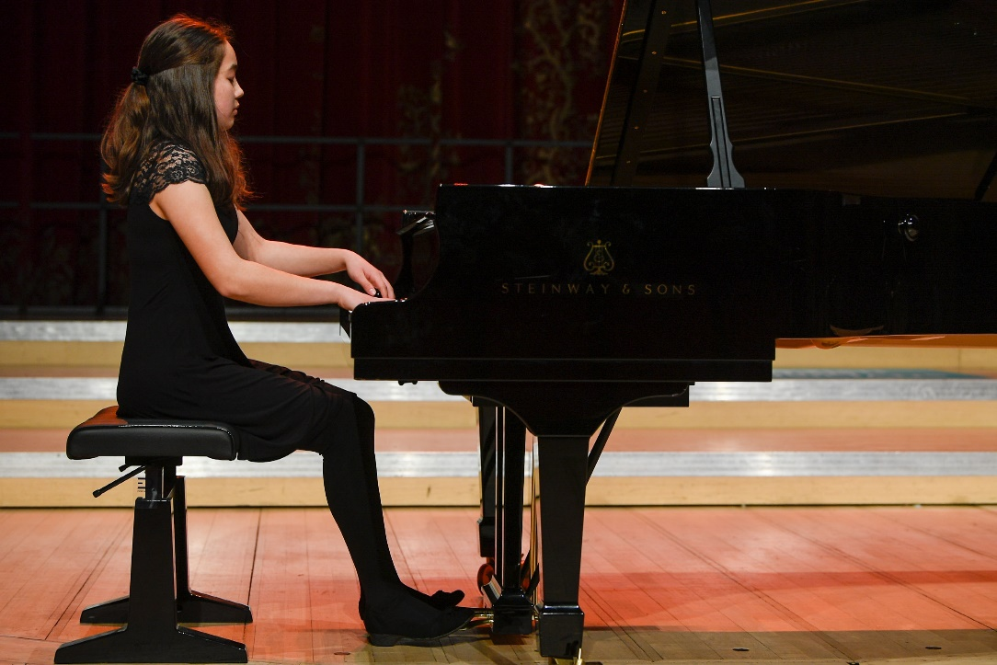
Juliet Robertson, 14-year-old pianist from Stirlingshire, and the winner of the first ever Scottish Young Musicians Solo Performer of the Year in 2022
Scottish Young Musicians, Scotland's leading festival of music competitions, is returning for 2023 to find Scotland’s best solo performer and ensemble. Young musicians from around the country will compete to win big prizes and perform live on a national stage in front of internationally renowned judges. This year more local authorities are taking part than ever before to offer young people around Scotland the opportunity to take part in this career-enhancing competition.
In 2023, more local authorities are taking part than ever before, giving opportunities to more young people who would like to compete. Each area will select their best local soloist to compete at the National Final at the Royal Conservatoire of Scotland on Sunday 21 May 2023.
Solo Performer of the Year is open to all young musicians who go to school in Scotland, whatever age or standard. Each local authority will select a regional finalist, with many hosting local and regional heats across different schools to decide who will represent the local authority at the National Final. Musicians can enter through their school music teachers and a finalist will also be selected from Scotland's independent schools.
The finalists and their parent or carer will receive travel expenses and accommodation, arranged by SYM, if required. At the final, a panel of judges will decide who will be awarded the title of Solo Performer of the Year.
The deadline for entries is 31st March 2023.
Ensemble of the Year is an online competition open to ensembles of 3 to 12 players, in any genre or grouping of instruments. The ensemble must play together regularly in a formal group from a school or recognised music organisation. Members must be school students in Scotland but there is no minimum age or standard. One ensemble should be selected to represent each local authority, recognised music organisation, and Scotland's independent schools. Each local authority and group may have their own competitions to select their final entry.
The chosen entries will then be submitted for judging by our panel of esteemed adjudicators. The winning ensemble will be awarded the title of Ensemble of the Year and receive a cash prize to further their musical experiences, the Maid of Morven Trophy and an all-expenses paid trip to play a prime slot at the Solo Performer of the Year National Final on Sunday 31st May at The Royal Conservatoire of Scotland. Thanks to a generous donation from Dr Ursula Jones OBE, there will be a special prize for one exceptional brass ensemble. This prize is donated in honour of her late husband Philip Jones CBE, who founded one of the world’s most celebrated brass ensembles.
The deadline for entries is 31st March 2023.
The winners of the Solo Performer of the Year and Brass Ensemble of the Year will receive a stunning trophy designed and donated by Alexander Stoddart, the Queen’s Sculptor in Ordinary in Scotland. The aluminium figure depicts the Maid of Morven, a figure from Ossianic poetry that has inspired composers throughout history. Finalists will also have a chance to win amazing career-changing prizes including cash to spend on developing music skills, a hand-crafted trophy, coaching, recording sessions, meet-and-greets with Scotland’s top music institutions and more.
Last year’s competitors reported increased confidence, musical skill, and new connections with other young people after taking part in the final, and one finalist even decided to change their career path and is now looking to study Musical Theatre at university after their success in Scottish Young Musicians and the increased confidence it gave them. Music Educators also noticed increased confidence, musical skill and mental wellbeing in their pupils who took part.
With more local authorities taking part in 2023 it is hoped that these effects will be replicated and even more widely spread.
For more information, please visit www.scottishyoungmusicians.com or follow the festival on Facebook, Twitter and Instagram.

Alan Kerr, Chair of Scottish Young Musicians, said: “After a fantastic start in 2022, we’re excited to bring back Scotland’s national festival of music competitions with more Local Authorities taking part and an ensemble competition open to all kinds of instruments. We’re delighted to be able to offer young people across Scotland the opportunity to grow in confidence, level up their skills, meet other young musicians, win big prizes!”

Nicola Benedetti CBE, Violinist and Director of Edinburgh International Festival, said: “We are currently in a rare and beautiful moment in Scotland’s history, where a phenomenal combination of individuals and organisations are tirelessly working together to achieve the highest possible inclusivity and excellence in music, all equally committed to enriching our national story and legacy, and furthermore, we have governmental commitment to free instrumental tuition for Scotland’s young people. It feels like such an exciting time for classical music in Scotland. Scottish Young Musicians offers the chance to celebrate the brilliant young musical talent across the country and as we move towards the National Final, I am excited to see how it develops.”

ENDS/
IMAGES AVAILABLE HERE
Press Contact:
For any press enquiries on Scottish Young Musicians, please contact
Hannah Knox hannahk@thecornershoppr.com / 07783748880

NOTES TO EDITORS
About Scottish Young Musicians
The story started over 20 years ago when brothers Alan and Brian Kerr founded the North Ayrshire Young Musician Competition. It has flourished ever since under the stewardship of Mae Murray and over 20,000 young musicians have enjoyed taking part. From this grew the idea of bringing the Scottish Young Musicians competitions to the whole of Scotland - and that is what they are now setting out to do.
About MEPG
The Music Education Partnership Group (MEPG) will oversee the running of the Scottish Young Musicians Competitions. MEPG brings together stakeholders in music and education across Scotland. MEPG is a registered charity and members organisation which aims to tackle inequity, help young people to realise their potential and challenge perceptions of music education.
About Alan Kerr
Alan Kerr has been a been a trustee of both Orchestras Live, the UK’s agency for orchestras, and for nearly 20 years, The Academy of St Martin in the Fields, the world’s most recorded chamber orchestra. He spends much of his time helping young musicians by nurturing excellence amongst those from deprived backgrounds. With his brother he founded the Ayrshire Young Musician Competition, which has had over 10,000 participants, and has expanded this into the creation of Scottish Young Musicians, Scotland’s national festival of music competitions. Alan is also a widely published music and charity industry photographer.

